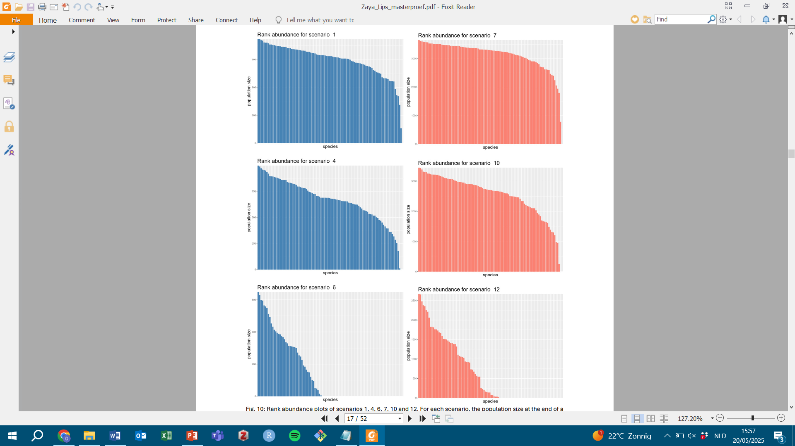
S.6.2 Rank abundance plots
Figure S.6.2: rank abundance plots for six scenarios. Each plot shows the final population size of all species present in a given scenario, ordered from highest to lowest. Scenarios on the left include only Natura 2000 grasslands; those on the right include all suitable grasslands in Flanders. Scenarios 1 and 7 represent an environmental temperature of 12.01 °C, scenarios 4 and 10 correspond to 13.35 °C, and scenarios 6 and 12 to 15.05 °C. Plots are based on a single replicate per scenario.

